**Practical-1**

**AIM:-**

**Create a webpage demonstrating “Spoural Event '' and its description, providing a link for the registration page. The registration form of the student for “Spoural Event'' has different fields like the type of event, event listing, Student ID/Group, Branch, etc.**

**Source Code:-**

1. **Home page:- Spoural_Event_Home.html**

<!DOCTYPE html>

<html lang="en">

<head>

    <meta charset="UTF-8">

    <meta http-equiv="X-UA-Compatible" content="IE=edge">

    <meta name="viewport" content="width=device-width, initial-scale=1.0">

    <title>Spoural Events</title>

</head>

<body>

    <h3>About <a href="https://www.charusat.ac.in/" target="_blanck">Charusat</a> Spoural-The Cultural festival of Charusat</h3>

    <h3><a href="Registration_Form.html" target="_blanck">Register</a> your self for this event.</h3>

    <h3>copyright&nbsp;&copy;&nbsp;2022-2023</h3>

</body>

</html>

**Output:-**

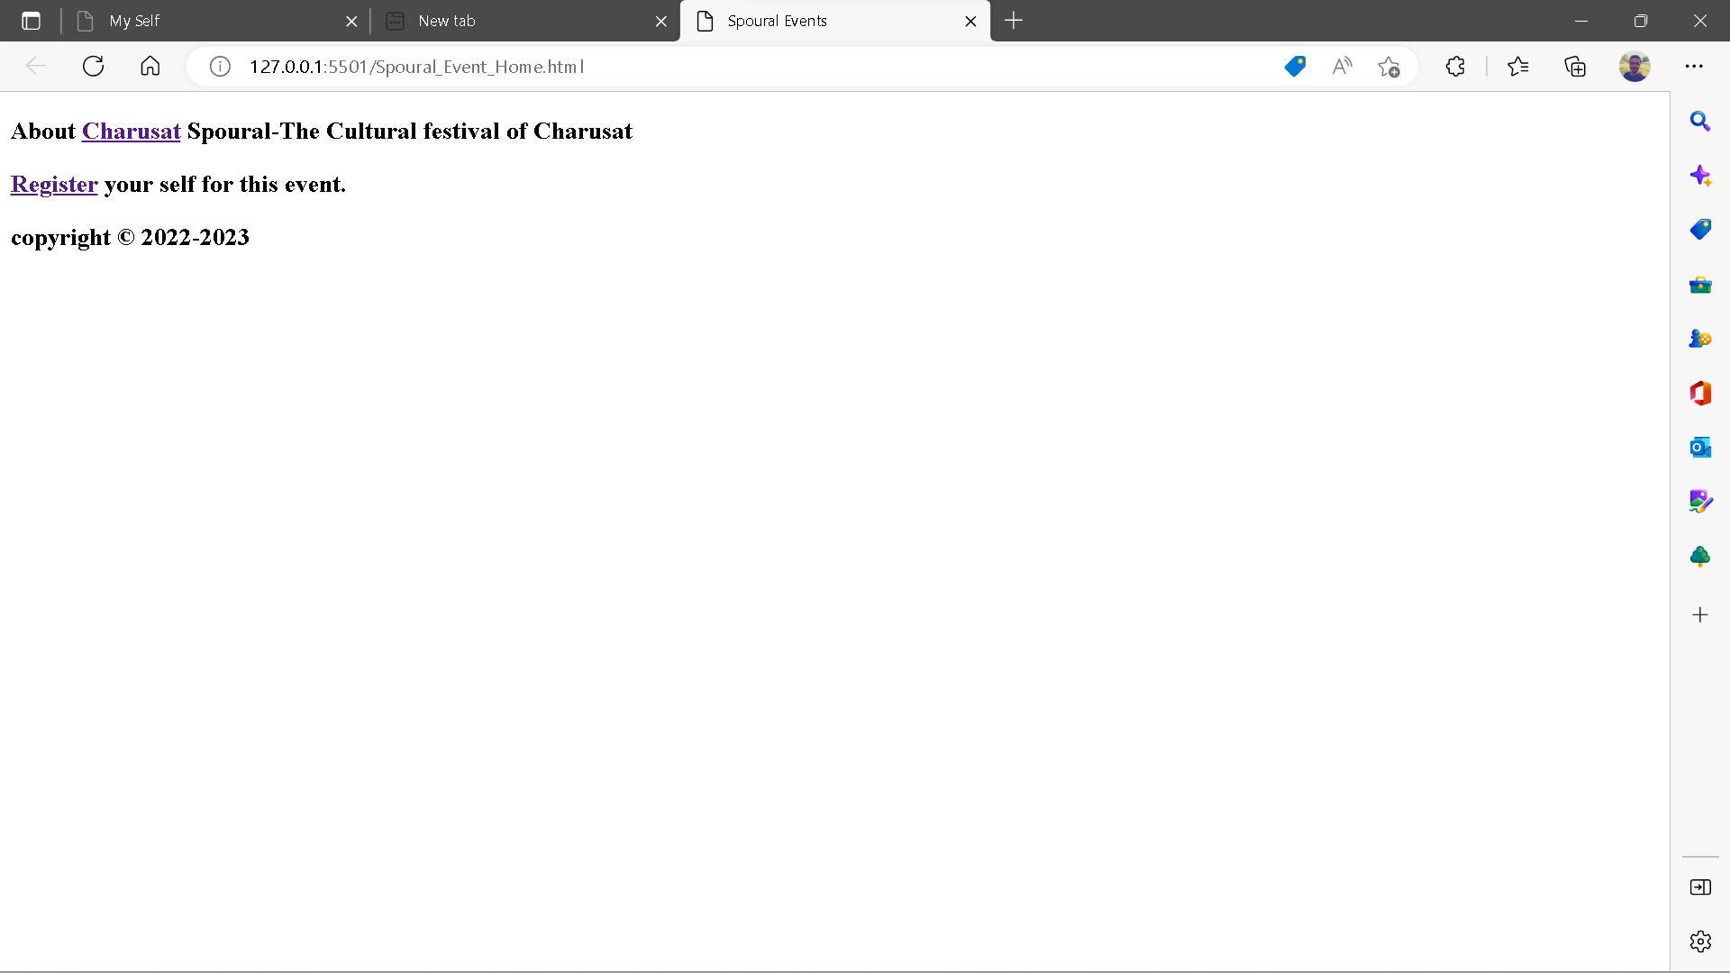

1. **Registration form;- Registration_form.html**

<!DOCTYPE html>

<html lang="en">

<head>

    <meta charset="UTF-8">

    <meta http-equiv="X-UA-Compatible" content="IE=edge">

    <meta name="viewport" content="width=device-width, initial-scale=1.0">

    <title>Registration form</title>

</head>

<body>

    <h3>The Events happen in Charusat University in Spoural.</h3>

    <ol>

        <li>Sport Activities</li>

        <li>Cultural Activities</li>

        <li>Student Hackthons</li>

        <li>Exhibinations</li>

        <li>Many Games</li>

    </ol>

    <h4>Fill this form and submit it to take part in Spoural 2023.</h4>

    <form action="Home.html" method="post">

        <label for="First Name">First Name</label>

        <input type="text" name="First Name" id="First Name" placeholder="First Name">

        <br>

        <label for="Middle Name">Middle Name</label>

        <input type="text" name="Middle Name" id="Middle Name" placeholder="Middle Name">

        <br>

        <label for="Last Name">Last Name</label>

        <input type="text" name="Last Name" id="Last Name" placeholder="Last Name">

        <br>

        <label for="Father's Name">Father's Name</label>

        <input type="text" name="Father's Name" id="Father's Name" placeholder="Father's Name(Full)">

        <br>

        <label for="Number">Contact Number</label>

        <input type="number" name="Number" id="Number" placeholder="Your Mobile Number">

        <br>

        <label for="textarea" aria-placeholder="Your address">Address</label>

        <br>

        <textarea name="Textarea" id="textarea" cols="30" rows="5" placeholder="Your Address"></textarea>

        <br>

        <h3>If you are the student of Charusat University then fill out the information given below.</h3>

        <label for="ID">ID Number</label>

        <input type="number" name="ID" id="ID" placeholder="Charusat's student ID">

        <br>

        <label for="Email">Email ID</label>

        <input type="email" name="Email" id="Email" placeholder="Your Email ID">

        <h3>Note: If your not the student of Charusat then Please Provide the personal email id.</h3>

        <br>

        <label for="College Name">Your College</label>

        <input type="text" name="College Name" id="College Name" placeholder="Your College Name">

        <br>

        <label for="Branch">Branch</label>

        <input type="text" name="Branch" id="Branch" placeholder="Your Branch">

        <br>

        <label for="Year">Current Year</label>

        <input type="number" name="number" id="Year" placeholder="Current year">

        <br>

        <br>

        <input type="button" value="Submit">

        <input type="reset" value="Reset">

        <br>

        <br>

        <a href="Spoural_Event_Home.html">Home Page</a>

    </form>

    <h4>copyright&nbsp;&copy;&nbsp;2022-2023</h4>

</body>

</html>

**Output:-**

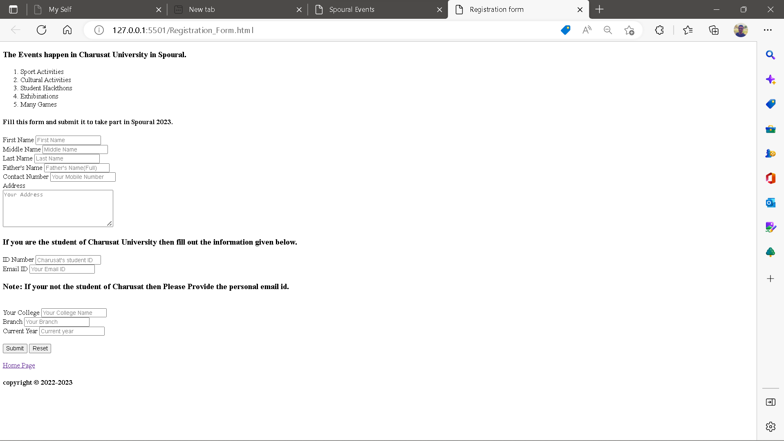

**Conclusion:-**

If we want to create such kinds of forms that take inputs from users and fill in their basic information regarding events then HTML is one of the easiest ways to do this thing. Just we have to write some code in HTML and upload it on social.

**Course Outcome:-**

From this, I learned how to create HTML forms and how to create a webpage using HTML.